Banking Application User Manual

CS 3230

Professor Yong Zhang

Final Project

Created by:

Porter Okey

Roque Dominguez

Nathan Cummings

# Table of Contents

**Table of Contents** **1**

**Creating a New Account** **2**

**Logging In** **3**

**Deposit Money** **4**

**Withdraw Money** **5**

**Transfer Money to Another Account** **6**

**Check Balance** **7**

**Logging Out** **8**

# Creating a New Account

Open the program and select Create New Account 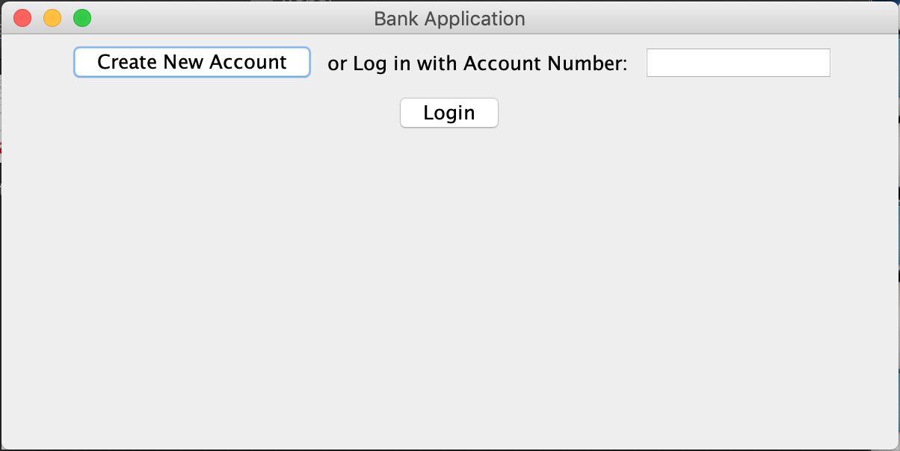

Your new account number will be displayed. Enter your first and last name in the respective boxes and click Submit. This will create your new account and take you back to the login screen.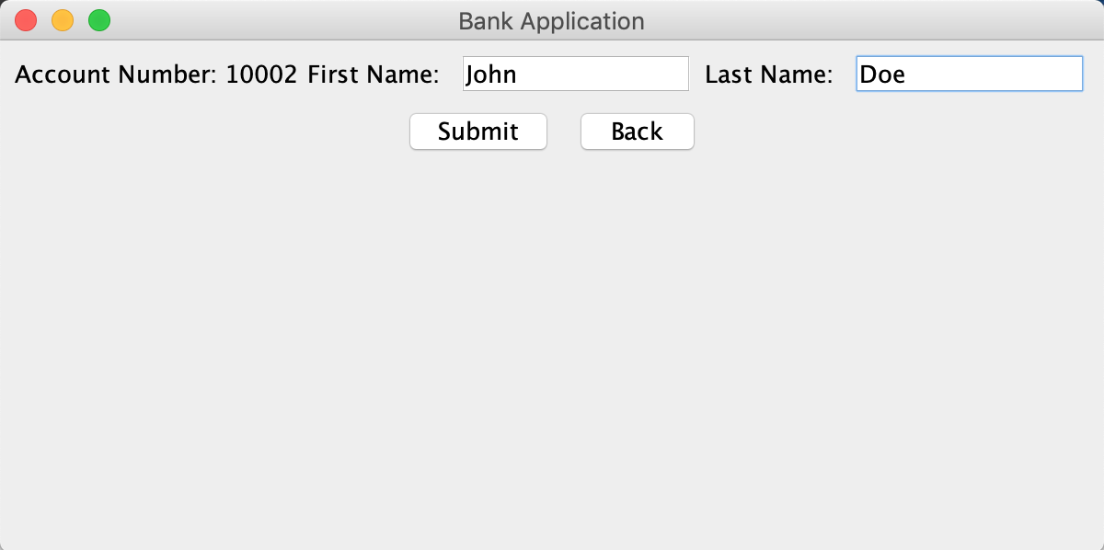

# Logging In

Enter your account number and select Login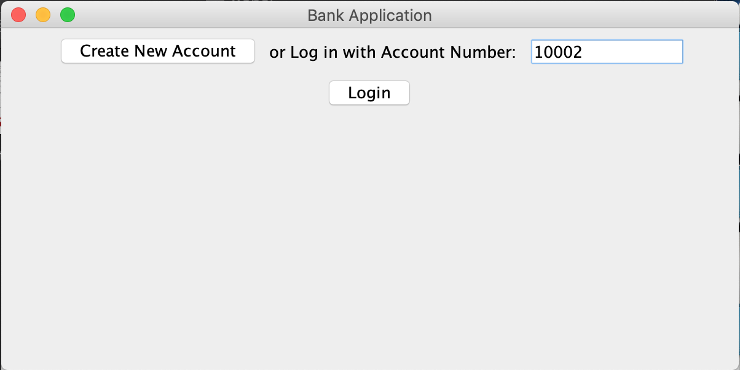The Main Menu screen should be displayed if you have successfully logged in.

# Deposit Money

From the Main Menu, select Deposit

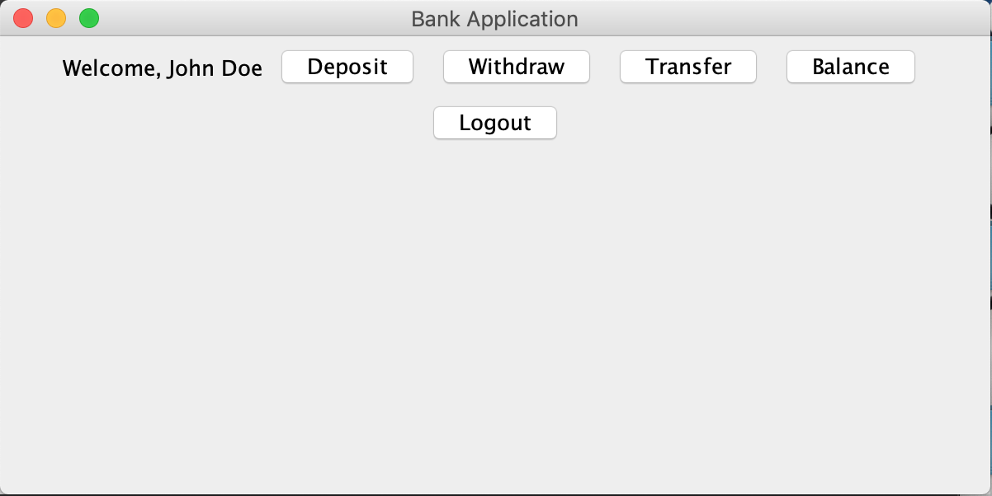

Enter the amount you would like to deposit and select Submit. The amount will be deposited to your account and you will be taken to the Main Menu screen.

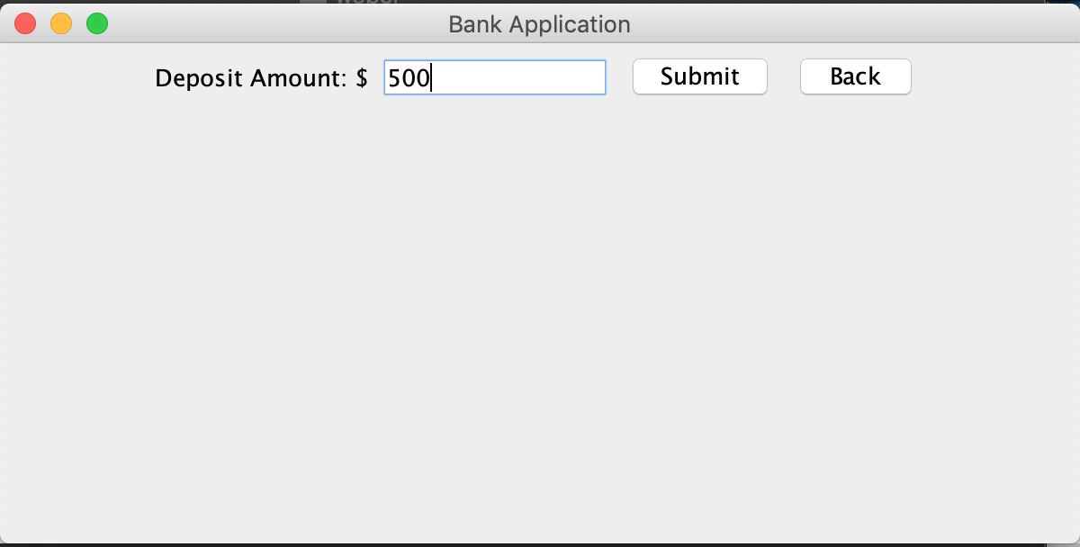

# Withdraw Money

From the Main Menu screen, select Withdraw



Enter the amount you would like to withdraw and select Submit. If you have a sufficient balance, it will withdraw the money and take you back to the Main Menu screen. If you have an insufficient balance an error message will appear. 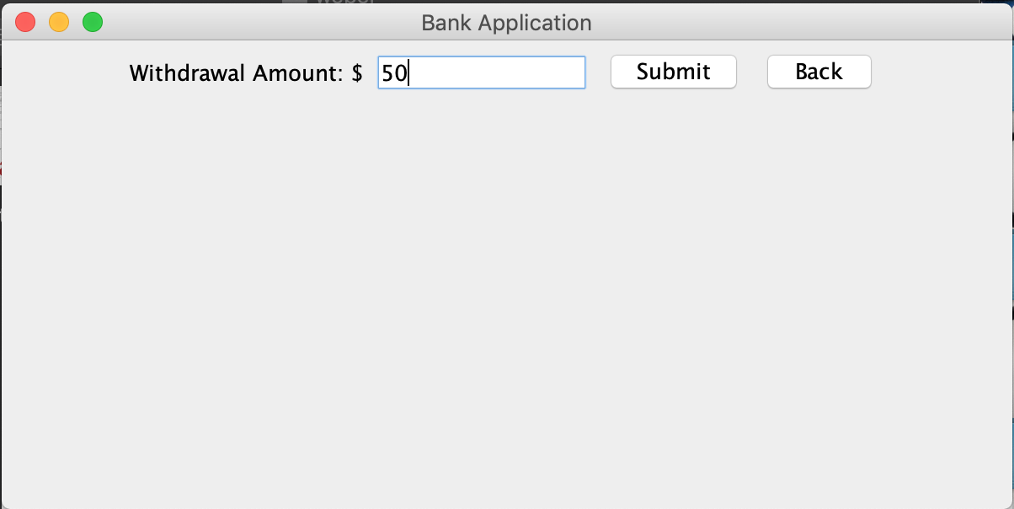

# Transfer Money to Another Account

From the Main Menu, select Transfer.



Enter the account you want to transfer to and enter the amount you want to transfer. The money will be withdrawn from your account and deposited into the account you entered. You will then be taken back to the Main Menu Screen.

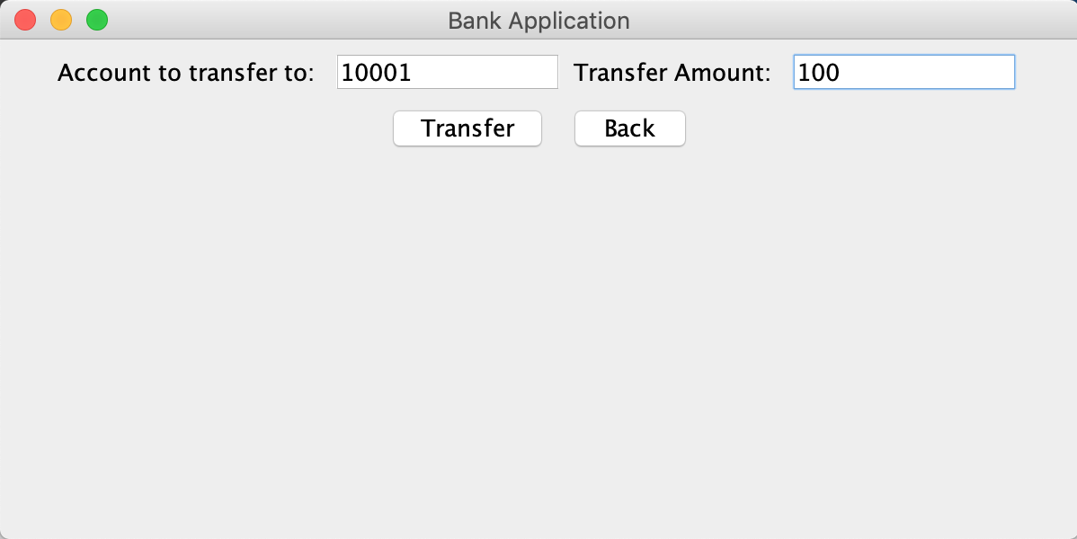

# Check Balance

From the Main Menu, select Balance.

Your balance will be displayed. You can select Back to go back to the Main Menu.

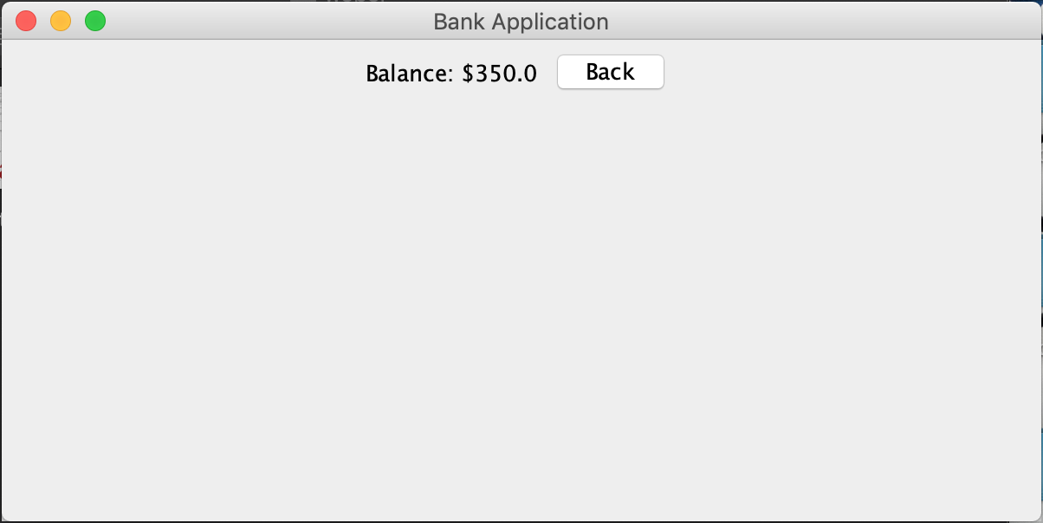

# Logging Out

From the Main Menu, select Log Out.

You will be taken back to the Login screen

